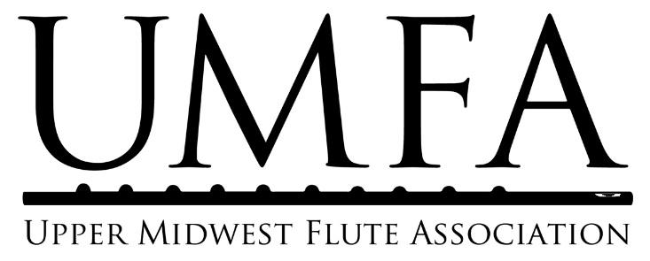

UMFA Scholarship Program Overview and Student Application Form

Program Overview
UMFA’s scholarship program supports local flute students in their music studies. Students who demonstrate financial need and dedication to their musical studies may apply to receive scholarships to help cover the costs of private lessons, master classes, summer music camps, or instrument rentals. Students of all ages and playing levels who are residents of the Upper Midwest may apply for scholarships.

To provide further support for students, UMFA partners with the MusicLink Foundation and with Hopewell Music Cooperative North. If students need instrument loans and/or additional financial assistance, they are encouraged to register with one or both of these partner organizations. More information is available below.

The UMFA scholarship program provides opportunities for students to apply for scholarships three times a year to cover musical studies during the periods of January 1-April 30, May 1-Aug 31, and Sept 1-Dec 31. Students who have received UMFA scholarships will be eligible to re-apply for additional scholarships. Checks will be disbursed directly to the teacher, master class organizer, or music camp with whom/where the student is studying.

UMFA’s Partner Organizations
The MusicLink Foundation is a national organization with a Minnesota chapter that helps to support low-income music students with the costs of music, instrument loans, musical supplies, and summer camps. UMFA’s scholarship students may register with MusicLink in order to borrow flutes and receive extra financial support in their studies. MusicLink takes instrument donations year-round.
Hopewell Music Cooperative North (HMCN) provides underserved students access to affordable and high quality private lessons, ensembles, and courses as well as to safe and vibrant performance opportunities for community members. Hopewell commits itself to community building through offering instruction in music to ALL members of the community of North Minneapolis who want to participate regardless of ability or circumstances. HMCN accepts instrument donations year-round.

Eligibility Guidelines and Requirements
- UMFA Membership: At the time of application, students must be current members of UMFA. Students who need assistance with membership fees may inquire with the scholarship program coordinator about a possible waiving of fees.
- Age range: Any age of students (including college students and adults) is eligible to apply.
- Geographic area: Candidates must be permanent residents in the states of Minnesota, North Dakota, South Dakota, Wisconsin, or Iowa.
- Playing level: Students of all levels (beginner, intermediate, advanced) are eligible to apply as long as they demonstrate financial need and dedication to their musical studies in their documentation and letter.
- Other scholarships: Students may be current recipients of other scholarships or financial assistance for their musical studies; they must disclose information about all other financial assistance (possible or definite) in this application.
- Re-applying: Students who have received UMFA scholarships in the past are eligible to re-apply.

UMFA Scholarship Application Form

If you have questions about the application, please contact the UMFA scholarship application coordinator at scholarship@umfaflutes.org. Applications must also be emailed to this address.

Scholarship Period (circle/highlight one):* | January 1-April 30 | May 1-Aug 31 | Sept 1-Dec 31
Application due dates (postmark or scan/email): | November 1 | March 15 | July 15
*Students may only apply for one scholarship period at a time.

Have you received an UMFA scholarship before? (Circle/highlight one and add details if answer is “yes.”)
No | Yes 🡪 Please list amount(s) received and scholarship period(s) (spring/summer/fall, year).

Disbursement Information
Purpose of funding (circle/highlight): | Private lessons / Music camp / Master class / Instrument rental
Name of teacher/camp/master class/instrument rental organization to receive funds:*
Teacher/Institution phone number(s):

Teacher/Institution email address:

Teacher/Institution mailing address:

*For private lessons, please clarify whether funds should be disbursed to your teacher or, if they teach through a music school, to that organization.

Student/Parent Contact Information
Student’s full legal name

Student’s age and year in school

Parent(s)’ full legal name(s):

Permanent address

Mailing address (if different from permanent address)
Home phone number

Cell phone number(s)

Email address(es)

UMFA Membership
Student membership: I hereby certify I am a current UMFA member or have submitted my member application. ____________________________________ (student or parent signature)
Form available at http://umfaflutes.org/membership. You may submit it online or include it with your scholarship application. Assistance with membership fees is available; contact scholarship@umfaflutes.org for details. The UMFA membership year runs from September 1 to August 31.

UMFA Scholarship Application Form
Documents to submit:
Responses MUST be typed.

- Application form (previous page)
- Teacher recommendation form: Your current or intended flute teacher, school band director/music teacher, or other school teacher (if you have not yet begun flute lessons and you feel that another teacher can provide a more complete recommendation) must submit the form at http://umfaflutes.org/scholarships via mail or email.
- Demonstration of financial need:
  - Letter(s) from the student and/or parent (see below)
  - School-aged students: If you or your student receives a free or reduced lunch, please attach a copy of your letter.
  - School-aged, college, and adult students: Please submit a 1040 tax form with sensitive personal information (i.e. social security number) blacked-out.
  - A list of any scholarships or financial support you have applied for to assist with the upcoming scholarship period (e.g. another summer camp scholarship) and any scholarships or financial support you have received for musical studies in the past or for the upcoming period. Please include whether you are currently registered as a student of MusicLink and whether you have been in the past.
- Letter(s) from the student/and or parent
  - Note: Students under 18, depending on age/maturity, may either submit a single letter from the parent with all of the below information OR two letters, one from the student (about their dedication to flute studies) and one from the parent (about financial need and commitment to supporting student’s studies).
  - Financial need:
    - Please include: (1) how much scholarship money you are requesting (both the maximum amount of financial aid that you would like to receive and the minimum amount that would make the scholarship useful to you; see note below), (2) why you need this scholarship and (3) why your musical studies on the flute are important to you.
    - Note: The amounts listed will not affect your chances of receiving a scholarship. Depending on available funding, UMFA may sometimes be able only to provide partial scholarships. You may ask for a maximum of $599 total each calendar year (January 1 – December 31).
  - Instrument: Do you have a flute in good working order?
    - If you need a flute, you may register as a MusicLink or Hopewell student (see page 1). If you don’t already have a flute, please include information about your plan to access one.
  - Teacher Information: If you are currently studying privately with a flute teacher, or if you have in the past, please list the teacher(s) with whom you have studied and the time periods you studied with them (e.g. Jane Doe, May 2009-Aug 2014).
  - Flute Activities and Goals
    - Describe your/your student’s current and past activities that show your interest in and commitment to playing the flute.
    - How much time do you/your student practice each week (on average)? Why are you willing to commit this amount of time to flute and music?
    - What do you/your student expect or want to learn from your studies? Tell us about your goals.

Signatures
I attest that the above and the attached information is true and complete to the best of my knowledge.
*If typed, this is considered a valid electronic signature.
Signature of parent/guardian of student Date | Signature of student Date

